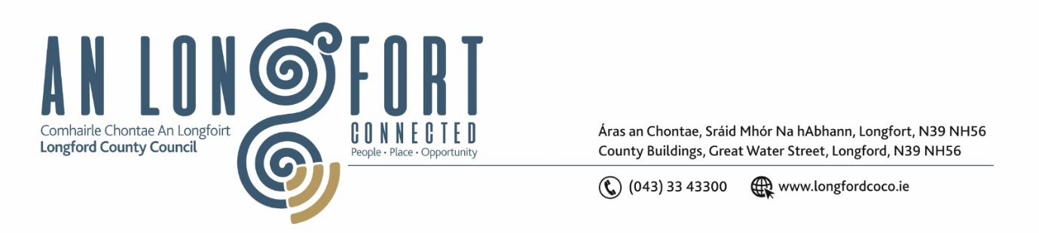

**LONGFORD MUNICIPAL DISTRICT**

***Please note meeting will be held in the Council Chamber, Aras an Chontae and via Microsoft Teams***

**18 January 2022.**

**To: Each Member of Longford Municipal District.**

**Dear Member,**

You are requested to attend the Meeting of Longford Municipal District to be held in **the Council Chamber, Aras an Chontae** and **via Microsoft Teams** on **Wednesday 25 January 2022 at 3.30pm** to transact business, as set out on the agenda hereunder.

**Yours sincerely**,

_______________

**Claire McNabola**

**Meetings Administrator**

**AGENDA**

Prayer before meeting.

**1.** Confirmation of Minutes:

1. Longford Municipal District Meeting held on Wednesday 23 November 2022 – enclosed.

**2.** Matters arising from Minutes.

**3.** Declaration of Interest by Members.

**4.** Management Report – enclosed.

**5.** Consideration and adoption of Draft Municipal District Report for inclusion in

Longford County Council 2022 Annual Report – enclosed.

**6.** Consideration of Part VIII No. 102 St. Rita’s – 1 No. existing single storey dwelling and the construction of 6 No. 1, 2 and 3-bedroom semi-detached single storey houses. It will also include boundary walls/fences, car parking, pedestrian entrances, landscaping, connection to existing services and associated site works at St. Rita’s Park, Park Road, Co. Longford – enclosed.

**7.** Nomination for Cathaoirleach Awards

**8**. Consideration of the formation of a Festival Committee within the Municipal District

**9.** **Notices of Motions, submitted by Councillors, as listed hereunder –**

**Councillor Seamus Butler**

That Longford County Council will request TII to delist the N63 as a National Route from the N4 roundabout to the Ballyminion roundabout on the Athlone Road after all the current and pending works are finished on the Longford Town section. The new N63 would then be designated along the N4 and N5 and across Ballyminion. The previous Longford Town section would then convert to ‘R’ status. This, combined with the HGV prohibition signage, will be a generational change improvement for the betterment of Longford Town.

**Councillor Uruemu Adejinmi**

1. I call on Longford County Council to remove the boulders and temporary fence along Great Water Street and clean up the rubbish trapped between the temporary and palisade fences to keep the area tidy.
2. I call on Longford County Council to purchase Compact equipment that cleans and disinfects our open spaces and other areas which are not accessed by the road sweeper machine.

**Councillor Gerry Warnock**

I'm requesting that Longford Municipal District commence the Part 8 Process to provide for the development of soccer facilities including an eleven-a-side pitch (to cater for Senior & Youth Football to specifications in accordance with FAI Guidelines), changing rooms and dugouts on part of the former Longford Greyhound Stadium site.

**Councillor Martin Monaghan**

1. I call on the Roads department repair the potholes in the Abbeycarton Lane and repaint the current walkway as it is in poor condition and badly faded in places.
2. I call on Longford County Council to review the current Taxi Ranks in the town